

MediaPlanner

Users Guide

12 August 2011

Updated:
15 May 2012
8 September 2012
11 September 2012

Contents:

1. Mediaplanner Basics 3
Purpose of MediaPlanner: 3
Overview of the Mediaplanner Process: 3
Quick Guide: 4
2. Mediaplanner detail 7
Open a Plan: 7
To change to a new or open an existing publication: 7
Create a new template: 9
Booking list 12
Export and Importing Advertisements: 13
Planning the publication: 13
Bookings Tab – See Figure 15: 14
Shape Library Tab – See Figure 17: 15
ID Layout Tab – See Figure 19: 16
Placing Advertisements: 16
Selecting a page: 17
Selecting an Advertisement on a page: 18
Icon task bar: 19
Tracking advertising material: 21
Completing the plan: 21
Summary of final planned pages: 23
3. Golden Rules: 24
4. Troubleshooting: 25
5. Glossary: 26

1. Mediaplanner Basics

This manual describes the basic functionality of MediaPlanner, although there are additional functions which are hardly used, and therefore not described in this manual.

Purpose of MediaPlanner:
MediaPlanner is software to plan a publication electronically. Both advertising and editorial information are used to setup a book plan. Advertising information is received through an interface from any advertising booking system, making the planning and placing of advertising bookings and material easy. Planning of editorial layouts are also easy and later in the production process the editorial layouts created in Indesign, can be linked to the planned pages in Mediaplanner. Placing advertising and editorial layouts in Mediaplanner will result in automatic page numbering of the Indesign pages.

Overview of the Mediaplanner Process:

Quick Guide:
This is a quick reference guide to start immediately with the basics of planning a publication. It is accepted that all templates have been created and are available and that the user did receive training on Mediaplanner previously. It is also advisable that the rest of the manual is consulted if more information is needed:

- To open MediaPlanner, click on the icon in you start menu or on the desktop.
- Click on the OPEN icon and select the issue, issue date and template, click OK.
- All booked ads will be brought into the plan, click PROCEED.
- An empty template will be displayed, unless a template with reserved information was previously created.
- Place advertisements by clicking and dragging them out of the booking list to the specific pages.
- Continue placing advertisements until all advertisements have been placed.
- Track the graphics to see a preview of the advertsing material.
- If required, place any editorial shapes out of the Ad Shape Library by clicking on the Library Tab. See Figure 15.
- Any InDesign layout information from Woodwing must also be place on the plan by selecting the layouts out of the OPERATIONID LAYOUT LIST.
- When pages are placed and no more changes will be made, select OUTPUTOUTPUT TO WOODWING DB to output those pages to Woodwing.
- Remember to save the plan on a regular basis.
- If pages move in the plan and they have been output previously, output the pages again by using the SEND LAYOUT TO WOODWING DB option by right clicking on the page. Please note when a page is output the second time with the OUTPUT TO WOODWING DB command, the adverts will move to their original position on the page.

On the next page is a workflow diagram showing the high level working of Mediaplanner.

* For specific commands/actions in Mediaplanner, that relate to the different process steps in the diagram above, see the table on page 6.

Ref. | Task | Action/Command in Mediaplanner
1 | Open the Plan | Click FILEOpen; or
1 | Open the Plan | Click the icon on the menu bar (Fig 4: Open Icon); or
1 | Open the Plan | Click on the issue date in the list on the left
2 | Open the Ads Booking list | Click the icon in the icon bar (Fig 15: Ads Picking List); or
2 | Open the Ads Booking list | Click OPERATIONADS PICKING LIST
3 | Drag and Drop ads | Click on the Bookings list icon; or
3 | Drag and Drop ads | Click on the Bookings tab at the bottom left hand corner; and
3 | Drag and Drop ads | Click and drag the ads from the list and place on pages
4 | Make ad graphic visible | Click on the track icon in the icon bar (Fig 26: Track Ads); or
4 | Make ad graphic visible | Click on the page number, right click and select Track Pages
5 | Save the plan | Click FILESAVE; or
5 | Save the plan | Click on the Save icon in the icon bar
6 | Open the Indesign Layout list | Click OPERATIONINDESIGN LAYOUT LIST
7 | Drag and drop layouts | Click on the layout tab at the bottom left hand corner; or
7 | Drag and drop layouts | Repeat step 6 to open the layout list; and
7 | Drag and drop layouts | Click and drag the layouts from the list and place on pages
8 | Amend the Plan | Click and drag the page to the new locations; or
8 | Amend the Plan | Click on the page number, right click on the new page number and select SWAP WITH PAGE#
9 | Output all elements | Click OUTPUTOUTPUT TO WOODWING DB
10 | Output a specific page | Click on the page number, right click on the page and select SEND LAYOUT TO WW

2. Mediaplanner detail

Open a Plan:
To open MediaPlanner, double click the icon on the desktop or click on STARTMediaPlanner. (These icons will be available when MediaPlanner is installed on your machine.) This will open the MediaPlanner page with the publication codes and issues that were previously planned and saved by the user that has logged on. Permissions will limit the Page Planner only to see his pages/plans. See Figure 1.

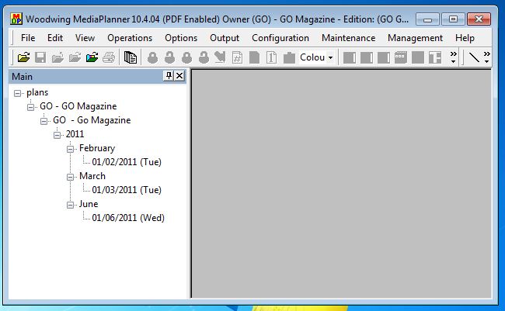
Figure 1: Main Screen

After MediaPlanner has been opened, the Main screen (Figure 1) will show. Most of the MediaPlanner menu and icon functions will be greyed out. These icons will be available when a plan is opened. The screen looks the same as any standard Windows screen with the title bar, menu bar, icon bar and the working space. On the left of the working space is a list of all the publication codes and already planned and saved issues.

To change to a new or open an existing publication:
There are three options to change to a different publication, publication date or template:

- From the FILE menu. See Figure 2: File Menu
  - Click on FILEOPEN, the ‘Current Selection’ screen will open.
  - Change the OWNER, EDITION and PUBLICATION DATE to the required publication.
  - Select the required template and click OK.

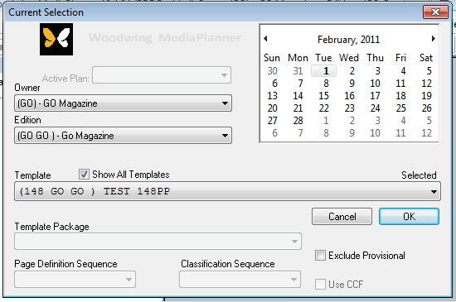
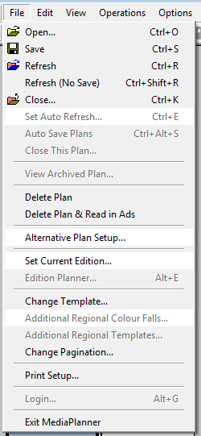

Figure 2: File Menu

- From the CONFIGURATION MENU. Refer to Figure 3: Configuration Menu:
  - Click on CONFIGURATIONCHANGE/OWNER/EDITION/DATE/TEMPLATE, the ‘Current Selection’ Screen will open.
  - Change the OWNER, EDITION and PUBLICATION DATE to the required publication.
  - Select the required template and click OK.
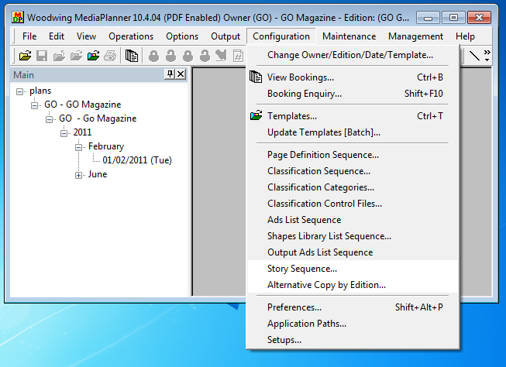

Figure 3: Configuration Menu

- Click on the OPEN icon. See Figure 4:
  - Change the OWNER, EDITION and PUBLICATION DATE to the required publication.
  - Select the required template and click OK.

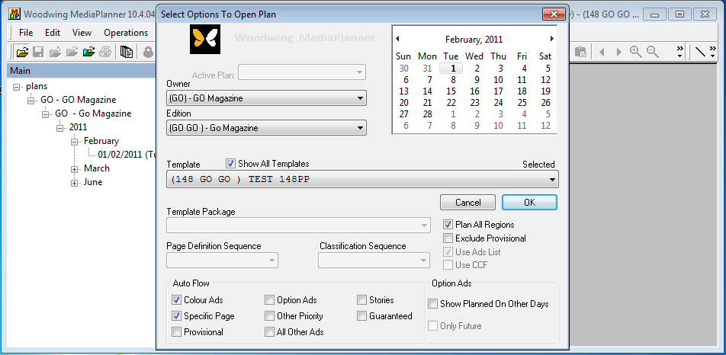
Figure 4: Open Icon

When all the selections are made, the Page Planner can continue importing the advertisements and place them on the pages. Refer to the Planning the Publication section on Page 13.

Create a new template:
A template is use to define and reserve standard spaces and book sizes for an issue, that will be used on a regular basis. Once a template is created, it requires little change, unless the layout of the publication changes.

To create a new template, select the template icon. See figure 5.

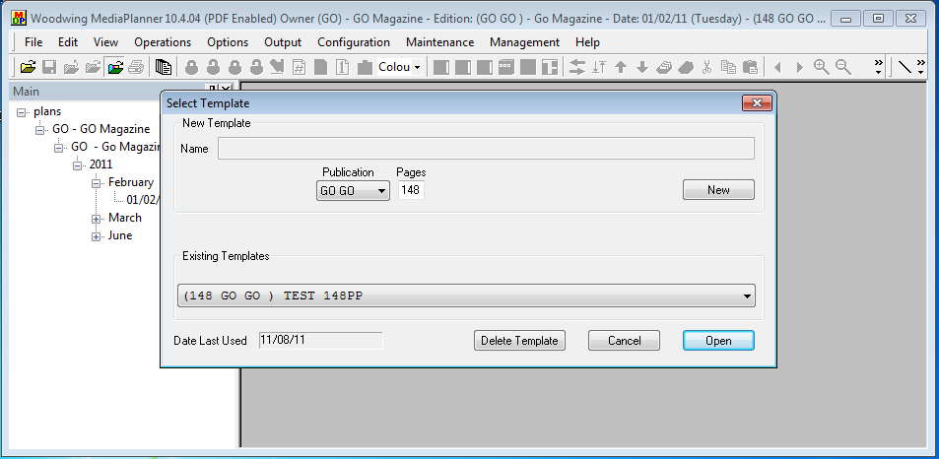
Figure 5: Template Icon

A template can also be created from the CONFIGURATIONTEMPLATES menu option and the same ‘Select Template’ screen will show. See Figure 6. Also refer to Figure 3: Configuration Menu, to find the Configuration menu item.

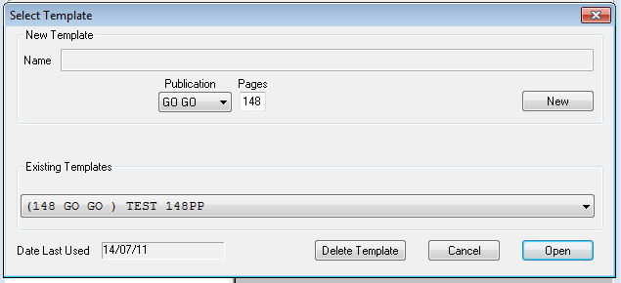
Figure 6: Select Template

Select the publication and type in the page size of the template to be created. If the publication code is not available, change to that publication as described on page 6. Click on ‘NEW’ to create the new template. Only after you have saved and re-opened the template the correct page detail will be shown.

The next step is to setup and define each Page Definition. Click on the Page Definition icon to add each page definition. See Figure 7. This is information to identify each page in the publication. The following Page Definitions are already created in Mediaplanner and can be allocated to each page:
- OFC – Outside Front Cover
- IFC – Inside Front Cover
- IBC – Inside Back Cover
- OBC – Outside Back Cover
- ROM – Run of Magazine

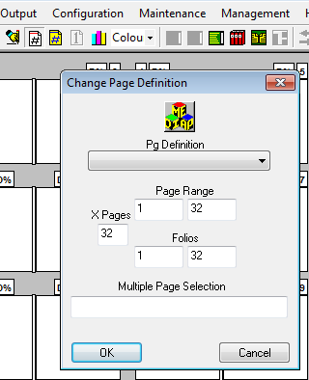
Figure 7: Page Definition

Other details can also be added by using the Page Details icon. See Figure 8. On the page details screen the following page information can be added for a page:
- The Page Definitions as described above.
- The colour detail of the page. Always select 4 Colour.
- Centre fold. Select the pages where the centre fold must be and click on Marker Centre. In the example below, page 72 and 73 is the centre fold high light by a CYAN colour.

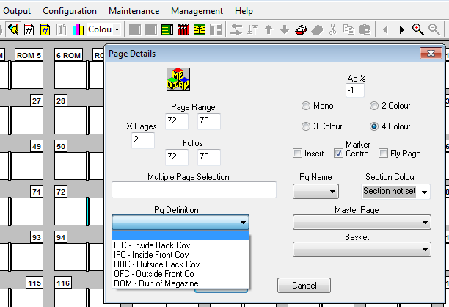
Figure 8: Page Details

IF the publication has a standard layout and design, these reserved spaces can also be loaded on the template. If the plan is then opened, this information is then already on the plan and minor adjustments need to take place, savind the page planner time. This can be done through the shapes library option as describe on page 15.

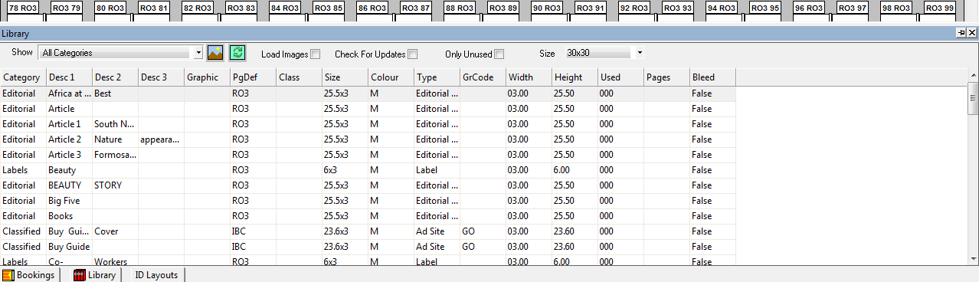
Figure 9: Shapes Library View

When all the detail of the template is completed SAVE the template. To save the template, click on FILESAVE or on the SAVE icon. When changes are made to a template and the template is closed, you will be promted to SAVE the template. See Figure 10.

Figure 10: File Save or Close

The ‘Save Template’ screen will show when closing or saving a template. See Figure 11.
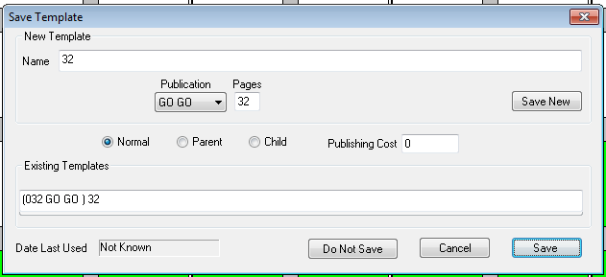

Figure 11: Save Template

Please note that once a template has been created, it is not necessary to change the naming convention of the template, unless the details of the number of pages have changed and the required template is not available or wanted to be saved under a new name.

If any of the page details need changing, the template either needs to be edited or new a template need to be created. As most magazines are always using the same page specifications and details, a template can be created only once. Changes made to the physical plan, which will not reflect on the original template. Also note that if a plan is saved, any changes made on a template will not reflect on saved plans.

After a template has been created, a new plan can be opened. To open a new plan click on FILEOPEN, select the specific publication, publication date and template and click OK. This will read all advertisements for that issue and date and open the plan. The advertisments can now be placed on the plan from the Booking list, at the bottom of the screen. See Figure 16: Booking List.

Booking list
To access the booking list click on CONFIGURATIONSETUPBOOKINGS. This will display all the bookings that came from the booking system in the .xml file. It will not be required to edit any information in this file as the information from the booking system should be correct. Refer to Figure 12 for an example of an advertisement in the booking list.

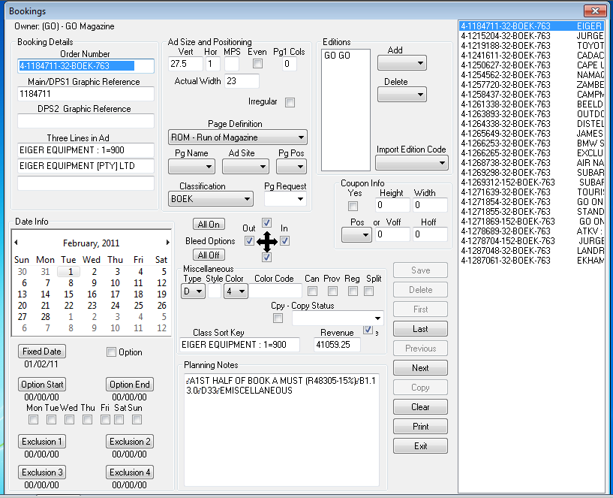
Figure 12: Ads Detail list

Export and Importing Advertisements:
Exporting advertisements from the booking system is not the responsibility of the Page Planner. The Account Manager that is handling the specific bookings is responsible to extract the advertisments when the deadline is reached. A .xml file will be generated and place in a predefined location for MediaPlanner to read the file. If this function is not completed, no advertisements will be available to plan. It is also important that when changes are made to an advertsiement, that the .xml file is generated again.

When the Page Planner opens the new plan for the specific publication, the advertisements in the .xml file will be read and brought into MediaPlanner. See Figure 13.

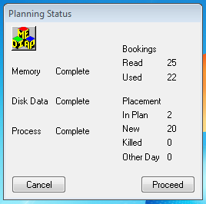
Figure 13: Planning Status

A summary of all the avertisements will be displayed in the Planning Status (Figure 13) screen. In the example above, 25 advertisements where imported of which, 22 will be used for the selected publication and date. Of the 22, 2 advertisements have been placed on the plan already. If this is a new plan, 0 advertisements will be ‘In Plan’. Click on PROCEED to open the plan and continue planning your publication.

Planning the publication:
After you have clicked on PROCEED, the complete plan will open. If it is a new plan, no advertisements will be visible on the plan and all advertising bookings will be listed in the Booking list. Also with a new plan, all the information loaded on a template, will be visible. See Figure 14.
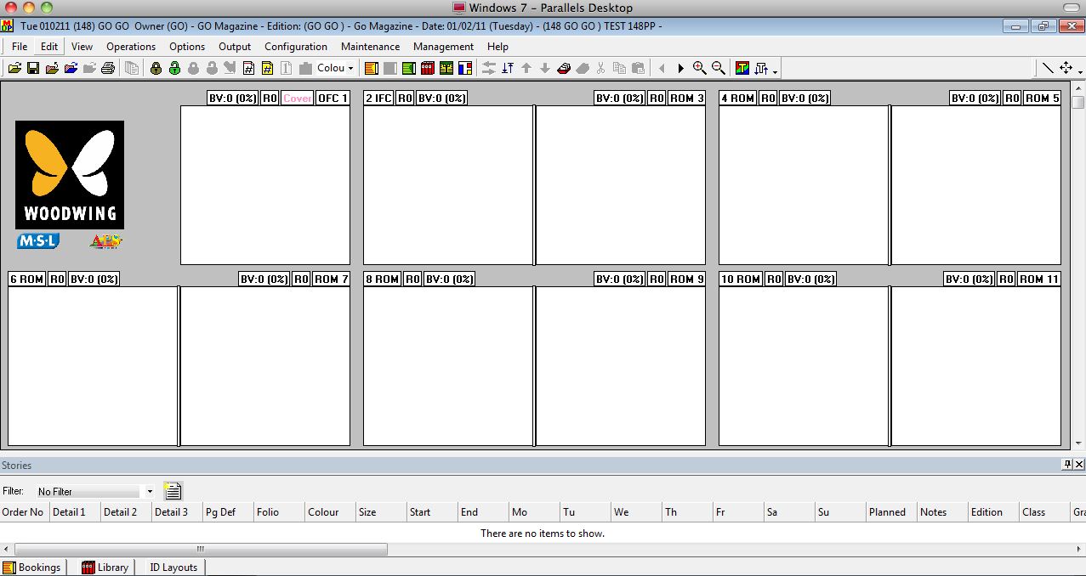

Figure 14: Plan View
Confirm that the publication detail in the title bar is the publication that had been selected under CONFIGURATIONCHANGE OWNER/EDITION/DATE/TEMPLATE and that this is the publication that you want to plan.

Also note that some icons at the top might be greyed out and are not usable on the page. More detail on all the icons and short cut keys will be handled at the end of the users guide. In the bottom left hand corner should be tabs for BOOKINGS; LIBRARY; ID LAYOUTS. If they are not there, activate them by following the steps below.

Bookings Tab – See Figure 15:
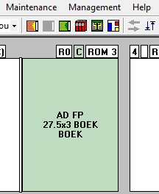
If the BOOKINGS list is not visible either click on the tab in the bottom left hand corner or click OPERATIONSADS PICKING LIST. You can also click on the icon in the icon task bar. Figure 15.
Figure 15: Ads Picking List

If you click on the bookings tab it will open a list of all the advertisements that are booked for the publication and date selected. It is from this list that advertisements will be moved onto the specific pages. Moving advertisements is done by clicking and draging the specific advertisement onto the specific page. Those advertisements that are not placed on a page will have a grey block infront of the booking description and those with a blue block have been placed on a page. This function can be switch on or off, depending on the user requirements. To do this, right click on the ORDER NO heading and select SHOW PLANNED ADS from the drop down menu. Figure 16.

Most of the functionality explained below, is very much the same as the standard functionality in Windows. For example:
  - Sorting the colom by clicking on the colom heading that needs to be sorted. Clicking again will change the sort order.

  - Adjusting the colom width by clicking and dragging on the line in between the two coloms.

  - Moving a colom by clicking and dragging on the heading of the colom and move it to its new location.

Each user can customise the layout of the screen according to his/her requirements.

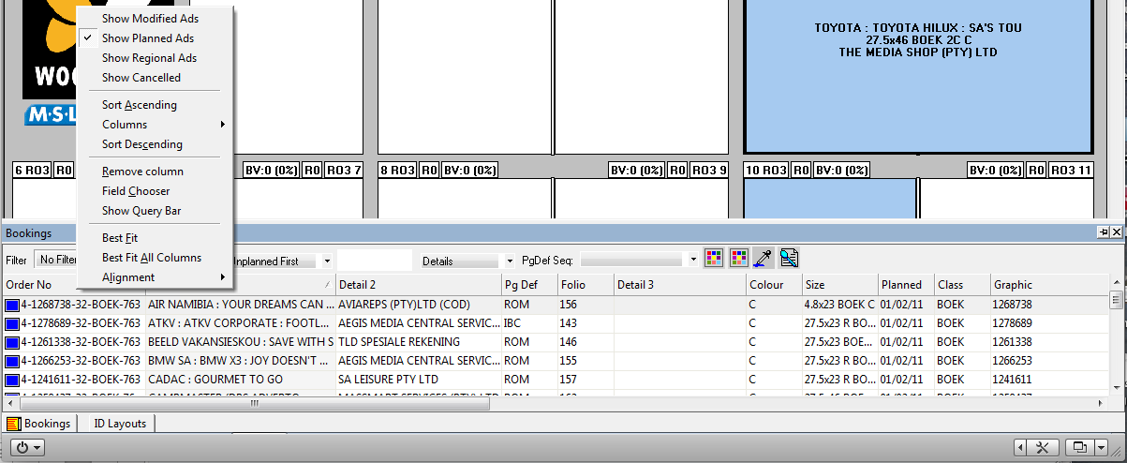
Figure 16: Booking List

Shape Library Tab – See Figure 17:
The library contains a standard set of shapes that can be used to prebook specific advertising and editorial spaces to reserve that space for later use. This can be advertising, editorial, advertorial, giveaways, promotions. The library shapes are pre-loaded and can be updated on a regular basis. If a library shape is placed on a page, it stays on the list of shapes to be used on other pages as well.

Figure 17: Shapes Library View

If this Library tab is not visible, click on EDITSHAPES LIBRARY PICKING LIST or on the icon in the icon task bar at the top. Figure 18.

Figure 18: Shapes Library Picking List

ID Layout Tab – See Figure 19:
The ID Layout tab is the view/link into Woodwing. When a bookplan is completed, the planned information needs to be passed onto Woodwing. This is a function that will be explained later in this document. When planned information is passed onto Woodwing, it will create automatically an InDesign layout for that specific page in Woodwing. When the layout is created in Woodwing, it will feed the layout detail back to MediaPlanner. This also includes editorial layouts. If this option is not available, click on OPERATIONINDESIGN LAYOUT LIST.

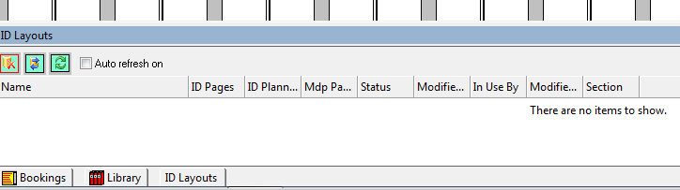
Figure 19: ID Layout View

In Figure 19, no layouts are created yet and no information is available from the Woodwing database. If information was available a list of the editorial layouts would appear which can be placed in the plan as well.

In the top left corner of this ID Layout window are three icons. See figure 20.

Disconnect from Woodwing DB: This is used to disconnect MediaPlanner from the Woodwing database. This is hardly used as no information will be available from Woodwing once it is clicked.
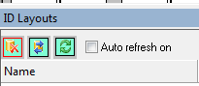
Re-log on to Woodwing DB: Sometimes a network problem might occur and the connection to Woodwing is lost. To re-establish the connection click on the icon and the connection will be establish automatically.
Refresh layout from system: This is to refresh the information in the list if any new layouts were added or created by the designers.

Figure 20: ID Layouts Icons

Placing Advertisements:
- When placing an advertisement on a page and the connection to Woodwing is established, please note that MediaPlanner will create the InDesign layout below the advertisement. This will not be visible, unless you move the advertisement to another page. It is also important that the InDesign layout should always stay with the advertisement. If the advertisement should be moved, make sure that the InDesign layout moves with the advertisement. In Figure 21 the Distell advertisement has been moved from page 3 to page 2. The InDesign layout stayed on page 3. Select both shapes and move them together.

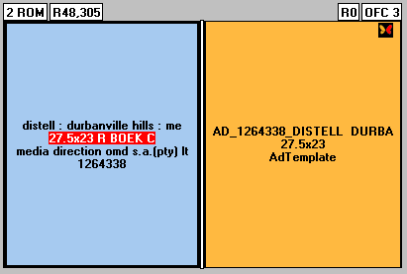
Figure 21: Placed Advertisements

- In the top right hand corner of the advertisement a Woodwing butterfly will indicate to you the status of the page. No butterfly means that the connection to Woodwing is broken or not available. It is important that the connection to Woodwing is re-established. The wings of the Woodwing butterfly will indicate the status of the page. Below is a description of the various colour coded butterflies:


When the right wing is red, it indicates that the connection to the Woodwing database has not been established. Reconnect to Woodwing.
When the left wing is orange, it indicates that the Indesign layout has been created when the advertisement is placed on a page.

.

In this example the orange wing is the same description as above.
The white wing on the right indicates that the connection to Woodwing is established.


The white wing on the right hand indicates that the connection to Woodwing is established.

A green butterfly indicates to the Page Planner that the specific page has been outputted to Woodwing

Selecting a page:
To select a page, click on the page number. For a left hand page, in the top left hand corner and for a right page, in the top right hand corner of the page. Right click with the mouse on the page number which will high light the page number. The following drop down menu will appear. See Figure 22. (not all functions are explained below). Please note the short cut keys next to each menu option:

Lock Page (Ctrl + L): Used to lock the page.

Track Page (Alt + T): Track the physical graphic if the graphic is available.

Select All Shapes (Ctrl + A): This option selects both the InDesign layout as well as the advertisement.

Insert pages (Alt + INS): Will insert pages in the plan an increase the book size with the number of new pages. This is handy when the book size increase as you don’t have to make changes to the template.

Delete pages (Alt + DEL): Will delete the selected page completely out of the plan. This is handy when pages is inserted and old pages need to be deleted or when the book size is smaller than the orginal template.

Change Page Def (Ctrl + G): This will change the page definition without changing the orginal template.
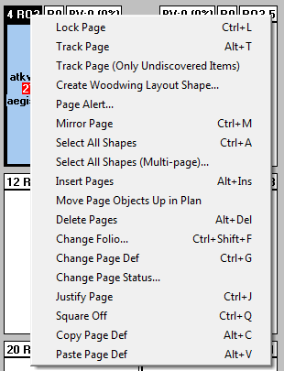

Figure 22: Page Number Menu

Selecting an Advertisement on a page:
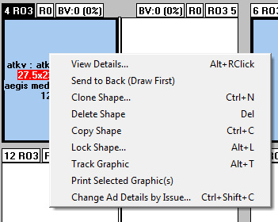
When you right click on the advertisement on a page, the following drop down menu will appear. Note that this is different to when you right click on the page number. See Figure 23.

Figure 23: Right Click Ad Menu

Drop Down menu Item - View Details: Shows the detail of the advertisement as received from the booking system. No changes can be made to the booking information. See Figure 24.

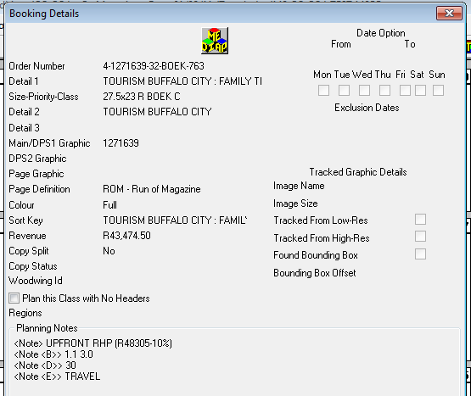

Figure 24: Booking Details

Drop Down menu Item - Modify Shapes: When an Ad Shape is place on a page the default description can be changed to the detail of that page as defined by the user.

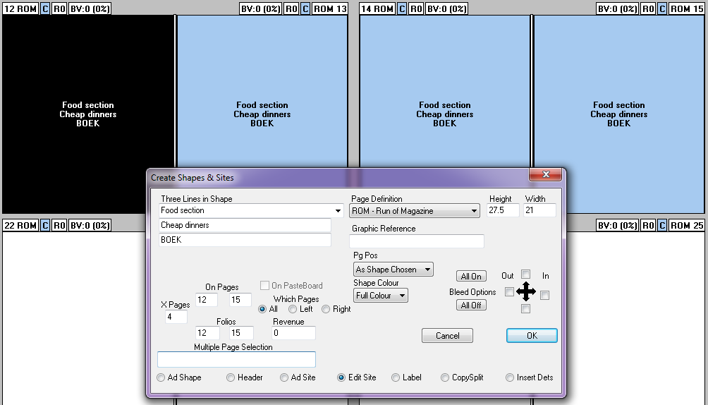
Figure 25: Clone & Modify Shapes

Drop Down menu Item - Clone Shape: Creates a copy of the current Ad Shape on the page. It is advisible to first place the shape on a page, then modify the details before cloning. This option should not be used with advertisements, but only with shapes. See Figure 25.

Drop Down menu Item - Delete Shape: Will delete the advertisement on the page. If the Select All Shapes option as explained above is used (see Figure 23), it will delete both the advertisement as well as the InDesign layout. It is important that when an advertisement is deleted from a page, the Indesign layout is deleted from that page as well.

Icon task bar:
Below is a description of all the icons in the icon task bar. Only those icons that are mostly used are explained.

When the mouse is hovered over an icon, a short description of that function will be displayed.

17
16
15
14
13
12
11
10
9
8
7
6
5
4
3
2
1

- Open (Ctrl + O): To open a previous saved plan or create a new plan.
- Save a plan (Ctrl + S): Will save the plan currently worked on. Plan will stay open and planning can continue.
- Close a plan (Ctrl + K): If changes were made, you will be prompted to save the plan or to abort the changes made.
- Refresh a plan (Ctrl + R): Will bring in any new advertisements that might be booked on the booking system. Placed advertisements will not be affected.
- Open a Template (Ctrl + T): To create a new template or edit an existing template. If a plan is open, this option is greyed out.
- Print a flat plan (Ctrl + P): Prints a flat plan of all pages.
- Lock a page: No changes can be made to that specific page.
- Unlock a page: If additional changes need to be made.
- Change Page Definitions (Ctrl + G): If it is required to change a page definition if different from the page definition that was predefined in the template.
- Open Ads List Window (F11): If the advertising booking list is not displayed at the bottom of the screen, this will open the window.
- Shapes Picking Library List (F12): Will open the predefined Ads Shape list.
- New Shape Library (Ctrl + N): If a non standard advertising shape needs to be created that is not in the Shapes Library List.
- Previous Set of Pages (Cursor Left): To move left in the plan
- Next Set of Pages (Cursor Right): To move right in the plan
- Bigger Pages (Cursor Down): To zoom into the plan
- Smaller Pages (Cursor Up): To zoom out of a plan
- Track Graphics (Alt + T): To replace the advertising space with the physical graphic if the graphic is available. The uniqie key number of the graphic is the link to that graphic and it is important that the all graphics are placed in the predefined location.

Tracking advertising material:
When all advertising booking information has been placed on a page, the adverts can be tracked to show you a preview of the physical advert. This can be done in a few ways:

- Click on the Track icon in the icon bar. This option will track all advertising pages. See Figure 26; or
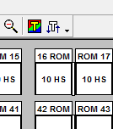

Figure: 26: Track Pages

- Select the page number, right click and select Track Pages from the drop down list. This option will only track the selected pages. See Figure 22: Page Number Menu

Completing the plan:
After all advertisements have been place and tracked, those pages can be passed onto Woodwing. Make sure that you have tracked the graphics, and see the preview of the advertisement, before output to Woodwing. Click on OUTPUTWOODWING DB and after the pop-up menu appears, select the pages that you want to output to Woodwing. See Figure 27. When editorial pages is place on the plan, the same process need to be followed to inform the layout artists of the new page number of his layout. Please note the change in the colors of the Woodwing butterfly in the top corner of the page. When a page number is selected, and the OUTPUTWOODWING DB option is selected, the page numbers will be completed automatically.

If a layout has been outputted to Woodwing previously, and moved to a new page, you must not OUTPUTWOODWING DB the layout again, but right click on the page and select, SEND LAYOUT TO WOODWING DB. This will only update the page number detail. If you do OUTPUTWOODWING DB, it will move the advertisements to its original position on the page.

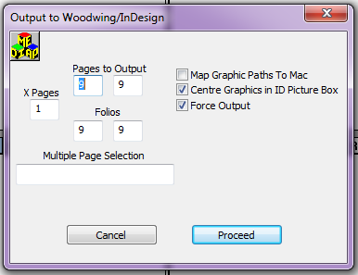
Figure 27: Output to Woodwing

When this is completed and the layouts are created in Woodwing, the information will be listed in the ID LAYOUTS screen. Any editorial layouts will also show in this list when the list is refreshed. The editorial layouts can also be placed on the pages. Please note that no graphic will be visible for editorial layouts.

Summary of final planned pages:

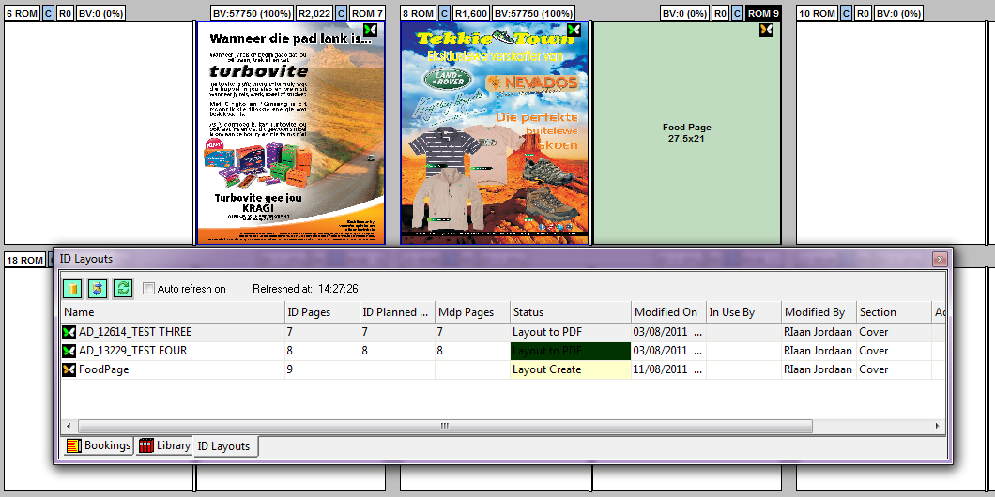
Figure 28: Final Plan Example

Above is an example of three pages that have been planned in MediaPlanner. The first two are full page advertising pages that have been placed from the booking list and then outputted to Woodwing. These pages are also listed in the ID Layouts screen below the planned pages. The Food Page is an example of an editorial layout that was created in InDesign, placed on the page in Mediaplanner and not yet outputted to Woodwing. The pages can be placed in the plan, by clicking and dragging from the list. Be careful and make sure that these pages are placed on the correct pages in MediaPlanner.

Only when you are sure that your plan is in its final stages, you can output the pages to Woodwing. If pages moves around in the plan after you have outputted them previously, remember to SEND LAYOUT TO WOODWING DB. This will only update the page number detail.

In the ID Layouts screen the following information is displayed:
- The name of the layout. For advertisements the standard naming convention derived from the order number of the booking. For layouts, it is the name of the InDesign layout given in Woodwing.
- ID Pages: is the number of the page this layout was created in Woodwing
- ID Planned Pages: When you output a page to Woodwing, this should match the ID page number.
- MDP Pages: is the page number on which page the advertisement was placed in MediaPlanner.
- Status: Is the layout status in Woodwing.
- Modified On: The timestamp as to when this layout was changed.
- Modified By: Who last worked and made changes to the plan
- Section: The section that was selected for Woodwing.

3. Golden Rules:
- Confirm that you are working in the right publication, publication date.
- Track graphics and only output to Woodwing those advertising pages that have a visible graphic.
- Only OUTPUTWOODWING DB once for a given page. If the layout artists have moved the advertisement in Indesign and this process is followed again, then it will move the advertisement to its original position.
- Place Indesign layouts from Woodwing also on the plan and OUTPUT WOODWING DB, to feed back the page number information to the layout artists. If the layout artists are using automatic page numbering in Indesign, this will automatically update the page number under the pages palette.
- If an editorial layout is moved to a new page in the plan and it has been outputted previously, do not follow the OUTPUTWOODWING DB option as this will move the advertisement to its original position on the page. Right click on the page number and select SEND LAYOUT TO WOODWING DB. This will only update the page number information in Woodwing. This can be done with advertisements as well.
- Placing an advert in the middle of an editorial spread, first place the advertisement and then place the editorial spread from Woodwing. This will force the editorial spread to skip the advertisement.
- When placing odd size ads, and Output to Woodwing, the layout artist must check the advertisement and make sure the advertisement is in the right position. That is why the planner must not Output to Woodwing that specific layout again, but SEND LAYOUT TO WOODWING DB to update page information only.
- Mediaplanner is setup with a fault tolerance of 99 points (about 34 mm or 17 mm on all four sides of the advert). It is important that advertising material is supplied within the specification of the trim size as per the rate card and the fault tolerance. When the document size exceeds the trim size and the fault tolerance, the advert will display with a red cross.
- If an Indesign editorial layout is moved in the plan, it is better to delete that plan and place it again from the list at the bottom of the screen.

4. Troubleshooting:

Problem | Solution
No graphics are tracked in Mediaplanner | Mediaplanner must have a drive mapping to where the physical PDF’s are stored.
When the layout artist opens the advert in Indesign, no graphic is visible | The layout artist must also have a drive mapped to the physical PDF location.
NATIVE error when the pages are output to Woodwing | The Indesign templates used in Mediaplanner must be setup with the same version of Indesign used by layout. If a template is of a previous version of Indesign, this error will occur.
Red Cross through the advert  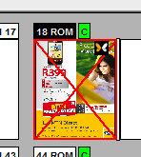 | It is important that advertising material must comply too the correct book size as per the rate card of the publication. If advertising material does not comply to the book size, the advertisement will appear in Mediaplanner with a red cross through the advertisement when you track the graphic. This will not stop the process, but the attention of the layout artist is required to correct the size of the advert or send the material back to the client and ask him to correct the advertisement according to the sizes specified on the rate card.
Advertisement shows a grey block, when opened in Indesign. | Track the graphic in Mediaplanner again and output to Woodwing.
Advert preview a black block when tracked in Mediaplanner  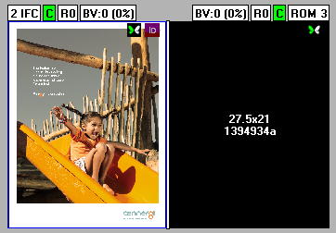 | This indicates that the PDF is corrupt and a new PDF should be requested from the supplier.
Woodwing Database Error | The connection from Mediaplanner has been lost. Refer to FIGURE 20 in the manual.
When opening a plan, no ads appear in the booking list | The ads information has not been exported by the booking clerk. Request the booking clerk to export the ads
PDF’s are available, but when tracked, no preview visible. | Confirm that the PDF’s have been exported with the correct keynumbers.

5. Glossary:

Bookings | More detail about the individual advertising booking received from the booking system.
Clone Shapes | To copy an existing adshape onto more than one page
Configuration Menu | This option controls the setup and configuration of Mediaplanner according to the requirements of the publication.
Edition | The publication name
ID Layouts | The Indesign Layouts that has been created in Woodwing and that can be placed on the Pageplan in Mediaplanner.
Marker Centre | The centre of the page template
Modify Shapes | To modify the adshape that has been placed on the page
Output to Woodwing | To output the complete planned pages to Woodwing.
Owner | Business name or Company Name of the publication
Page Definition | The details of each page in the template
Publication Date | The date when this issue or publication will go on Sale. Can be the cover date.
Shape Library | A library of standard shapes that is used on a regular basis. These are used to reserve spaces until the layout is available to plan.
Template | The standard book size of the publication. A template needs only to be created once. If the book size change, a new template should be created.
Track Graphics | Place the physical graphic of the advertisement on the page.
View Details | Viewing more details of the Layout or Advertisement
Woodwing Butterfly | The butterfly wing in the top right corner that will indicate the status if the page and connection to the database.
Woodwing DB | The Woodwing Database.
XML file | The details of the booked information in a standard layout format.

